SQL PROJECT
- LIBRARY MANAGEMENT SYSTEM
CORE TABLE :-
1-BOOKS – BOOK_ID , TITLE , AUTHOR_ID ,CATEGORY_ID , AVAILABILITY
2 – AUTHORS – AUTHOR_ID , NAME
3 – MEMBER – MEMBER_ID , NAME , CONTACT_INFO
4 – LOANS – LOAN_ID , BOOK_ID , MEMBER_ID ,ISSUE_DATE , DUE_DATE , RETURN_DATE

Relationships :
- Author → Books (1-to-many)
- Category → Books (1-to-many)
- Members ↔ Books (many-to-many via Loans)

ER DIAGRAM :
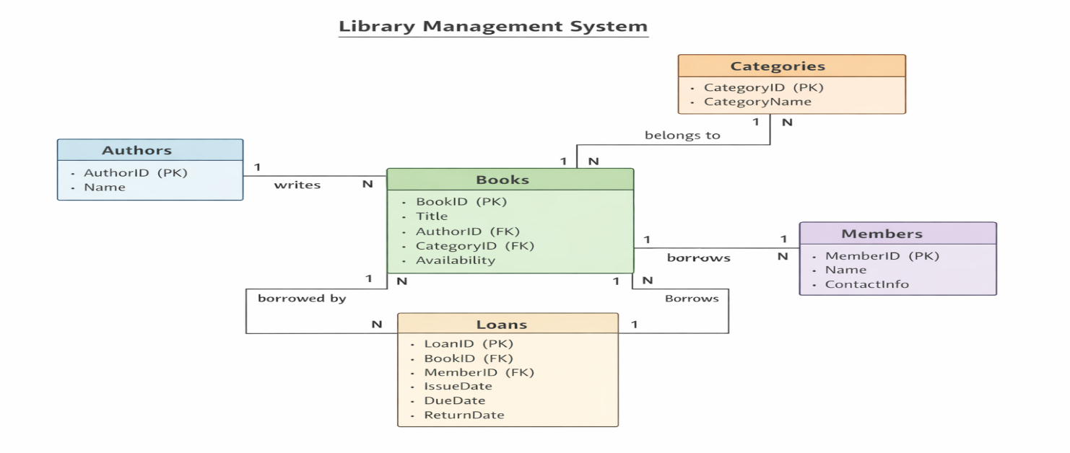
TABLE CREATION

1 AUTHOR TABLE ;- create table Author (
Author_Id int primary key Auto_Increment,
Author_Name varchar(100) not null);

2 CATEGORIES TABLE :- CREATE TABLE Categories (
CategoryID INT PRIMARY KEY AUTO_INCREMENT,
CategoryName VARCHAR(100) NOT NULL);

3 BOOKS TABLE :- create table Books(
Book_Id int primary key Auto_increment,
Title varchar(150) not null,
Author_Id int,
Category_Id int ,
Availability ENUM('Available','Borrowed') DEFAULT 'Available',
FOREIGN KEY (Author_Id) REFERENCES Author(Author_Id),
FOREIGN KEY (Category_Id) REFERENCES Categories(CategoryId));

4 MEMBERS TABLE :- create table Members (
Member_Id int primary key auto_increment ,
Member_name varchar (100) not null,
Contact_Info varchar(255));
5 LOANS TABLE :- create table Loans (
Loan_Id INT PRIMARY KEY AUTO_INCREMENT,
Book_Id INT,
Member_Id INT,
Issue_Date DATE,
Due_Date DATE,
Return_Date DATE,
FOREIGN KEY (Book_Id) REFERENCES Books(Book_Id),
FOREIGN KEY (Member_Id) REFERENCES Members(Member_Id));

INSERT DATA
AUTHOR :- INSERT INTO Author (Author_Name)
VALUES
('Harper Lee'),
('George Orwell'),
('F. Scott Fitzgerald'),
('Jane Austen'),
('J.D. Salinger'),
('Herman Melville'),
('Leo Tolstoy'),
('J.R.R. Tolkien'),
('J.K. Rowling'),
('Paulo Coelho');
CATEGORIES :- INSERT INTO Categories (CategoryName)
VALUES
('Classic Literature'),
('Dystopian'),
('Romance'),
('Historical'),
('Fantasy'),
('Philosophical Fiction');

BOOKS :- INSERT INTO Books (Title, Author_Id, Category_Id, Availability)
VALUES
('To Kill a Mockingbird', 1, 1, 'Available'),
('1984', 2, 2, 'Available'),
('The Great Gatsby', 3, 1, 'Borrowed'),
('Pride and Prejudice', 4, 3, 'Available'),
('The Catcher in the Rye', 5, 1, 'Available'),
('Moby-Dick', 6, 4, 'Available'),
('War and Peace', 7, 4, 'Borrowed'),
('The Hobbit', 8, 5, 'Available'),
('Harry Potter and the Sorcerer''s Stone', 9, 5, 'Available'),
('The Alchemist', 10, 6, 'Available');
MEMBERS :- INSERT INTO Members (Member_Name, Contact_Info)
VALUES
('Alice Johnson', 'alice@example.com'),
('Bob Smith', 'bob@example.com'),
('Charlie Brown', 'charlie@example.com'),
('Diana Prince', 'diana@example.com'),
('Ethan Hunt', 'ethan@example.com');

LOANS :- INSERT INTO Loans (Book_Id, Member_Id, Issue_Date, Due_Date, Return_Date)
VALUES
(3, 1, '2026-03-01', '2026-03-15', NULL),
(7, 2, '2026-03-05', '2026-03-20', NULL);

Query Practice Set — LMS Project
- Basic Retrieval
- List all available books.
- Show all members and their contact info.
- Display all books written by 'George Orwell'.

- Joins & Relationships
- List each book with its author and category name.
- Show which member borrowed 'The Great Gatsby'.
- Find all books borrowed by 'Alice Johnson'.

- Aggregates & Grouping
  - Count how many books are in each category.
  - Find the total number of books currently borrowed.
  - Show how many books each author has written.

- Date-Based Logic
    - List all loans that are overdue (DueDate < today and ReturnDate IS NULL).
    - Show all books borrowed in March 2026.
    - Find members who returned books late (ReturnDate > DueDate).

- Advanced Reporting
- Top 3 most borrowed books.
- Members who borrowed more than 2 books.
- Books that have never been borrowed.

- Insert (Adding Data)
- Add a new author named “Mark Twain.”
- Add a new category called “Adventure.”
- Add a new book “Adventures of Huckleberry Finn.”
- Register a new member “Sophia Williams.”
- Update (Modifying Data)
- Update the availability of “The Great Gatsby” to Available.
- Change contact info of member “Bob Smith.”
- Extend the due date of LoanID = 1 by 7 days.
- Delete (Removing Data)
            - Delete the book “Moby-Dick.”
            - Remove member “Charlie Brown.”
            - Delete all loans that have been returned.

- Challenge Workflows

- Issue a new loan: Sophia Williams borrows “Harry Potter and the Sorcerer’s Stone.”
- Return a book: Alice Johnson returns “The Great Gatsby.”

